How to train your dragon
Find one of these:
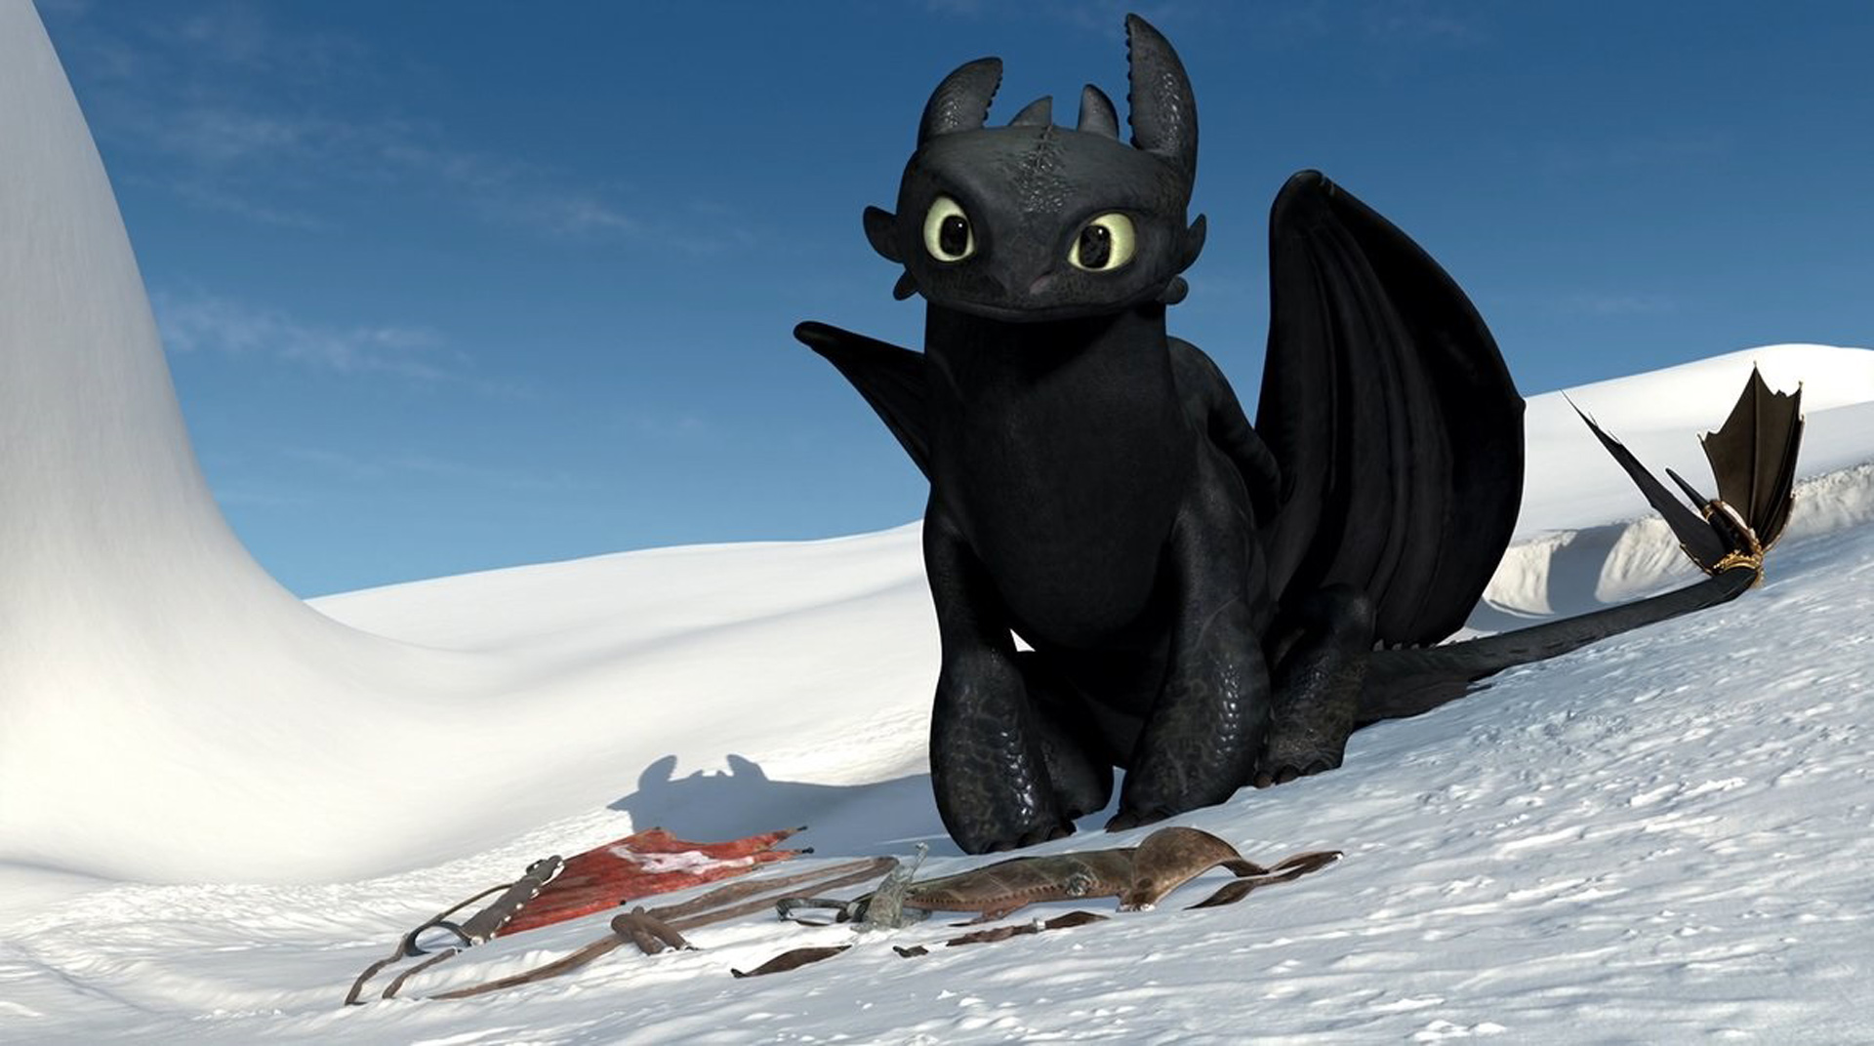
Then train it. Duh!

